To avoid biases
- Check correlation

After assessing a correlation
- Have you thought all options what contracting the evidence?
- At what moment is the correlation? always?
- How strong is the correlation?
- What did you expected? had you strong feelings this is true?
- Could it be biased by your previous expectations?
- There is a correlations but could it be only a coincidence?
- Did you find a correlation and a reason?
- How you gather enough data? at different places, moments?
- Can the correlation be explained by another hidden factors?

- Don't focus only on confirming evidence
- Ask whether expectetations affected judgment
- Factor in the possibility of chance

CORRELATION

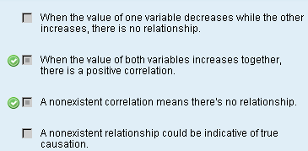

POTENTIAL MISSTEPS: BIASES

1) Egocentric bias: tendency to assume others think the same as you

2) Self serving bias:
- attributing the failure of others to dispositional factors and their successes to the situation
- attributing your failure to external factors and your successes to internal traits

3) Fundamental bias: overestimate dispositional factors and underestimate situational factors

Attribution-making Biases
Attribution-making Biases | Definition | Strategy
Fundamental attribution error | The tendency to overlook the influence of the situation on others' behavior, and to overemphasize personal traits instead | - Pay close attention to the influence of the situation on someone's actions.  - Ask yourself whether someone acts this way consistently or whether the circumstance dictated a behavior unrelated to his disposition.
Self-serving bias | The tendency to attribute the cause of your success to your traits or disposition and attribute your failures to the effects of the circumstance.  When making attributions about others, it's doing just the opposite. | - Remember that luck sometimes plays a role in your success as well as the failure of others.  - When solving problems, don't overestimate your ability to achieve success.  - If a decision fails, don't overestimate the personal control that others had on the situation.
Egocentric bias | The tendency to assume that other people experience events the same way you do | - After a significant happening, ask others about their perceptions of the event. Notice that, most of the time, the way others experienced an event differs in some way from your experience.  - When solving problems, take into account that others will think about a problem differently and perceive the success or failure of a decision in a different light.

Biases
- Hind Sight: don't take in consideration past experiences. AS IT WAS BEFORE IS NOW, nothing has change, the situation MUST be the same as in the past

- Configuration: You avoid facts that contradict your decision, and you support facts that support you

- Consistency: You don't change your mind easily once you decide, you keep your word

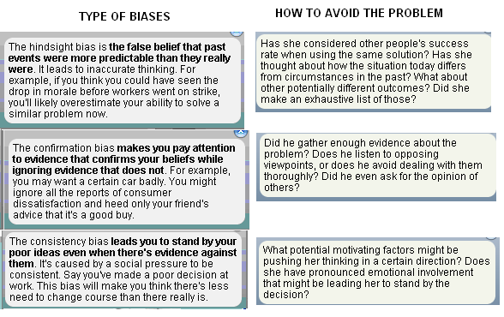

- Hindsight: Overestimate the predictability of the past
- Confirmation: Acknowledge only supporting facts, and avoid contradictory facts to your hypothesis
- Consistency: you don’t change your mind

Techniques to avoid biases

- List possible causes of past outcomes, brainstorm other possible causes not seen
- Purposely focus on contrary evidence. Look why you are wrong
- Examine your motives regarding the problem
- Gather more information, ask outsiders to look at the possible bias
- Focus on evidence against your hypothesis
- Use secret voting, avoid groupthinking

